Simulation of “A+ --> wait 2 sec --> B+ --> wait 5 sec -> A- --> B-“ sequence of 2 cylinders”

Submitted in fulfillment of the requirements of

ESZG511 MECHATRONICS

(Assignment)

By

Name: GODAVARTHI AAHLADH

(BITS ID NO: 2018HT01513)



BIRLA INSTITUTE OF TECHNOLOGY AND SCIENCE, PILANI

Work Integrated Learning Program

Second Semester 2019-20

**Hall Ticket:**

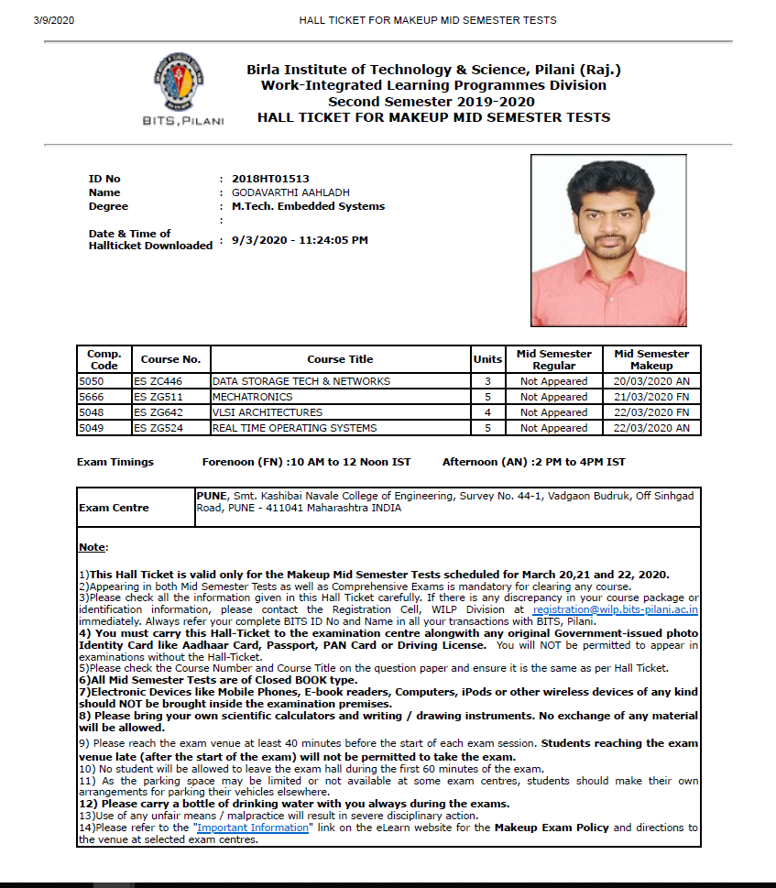

**Aim**

To simulate the following sequence of 2 cylinders “A+ -> wait 2 sec -> B+ -> wait 5 sec -> A -> B-“

**List of components required**

|  |  |  |
| --- | --- | --- |
| **Sl. No.** | **Component Name** | **Quantity** |
| 1 | Double acting cylinder (Pneumatic) | 2 |
| 2 | 5/2 solenoid operated DCV | 2 |
| 3 | Pressure source | 2 |
| 4 | Exhaust | 4 |
| 5 | Rung (Ladder for AB PLC) | 1 |
| 6 | PLC Input Card (Electrical Control (JIC Control) | 1 |
| 7 | PLC Output Card (Electrical Control (JIC Control) | 1 |
| 8 | NO Push button (Electrical Control JIC) | 1 |
| 9 | Solenoid | 4 |
| 10 | NO proximity switch | 4 |
| 11 | OTE | 4 |
| 12 | Pneumatic proximity sensor | 4 |
| 13 | ON Delay Timer | 2 |
| 14 | Examine if closed | 6 |
| 15 | OTE | 4 |
| 16 | 24V power source, 0V common | 2 each |

**Circuit Diagram**

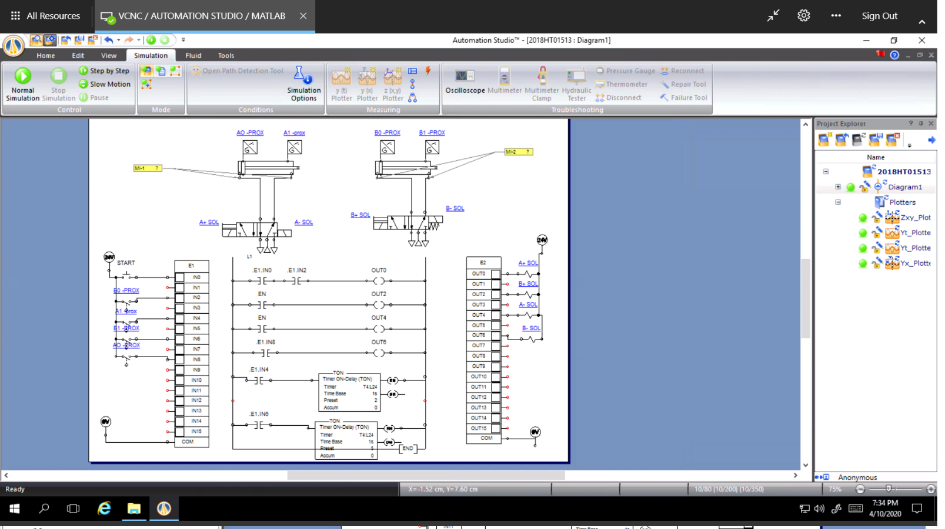

**(Please go to next page for clear picture)**

**Clear picture of circuit Diagram**

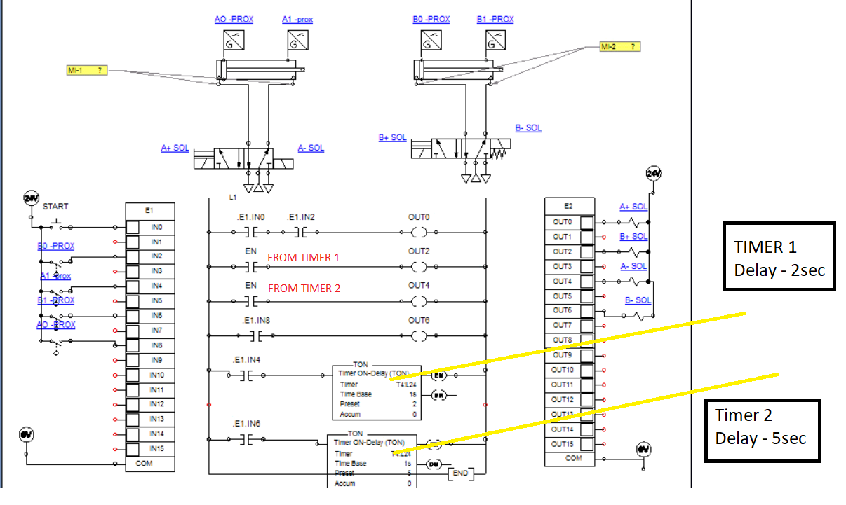

**Results and observation**

1. Differential Pressure value in psi of each cylinder (at fully retracted and fully extended position)

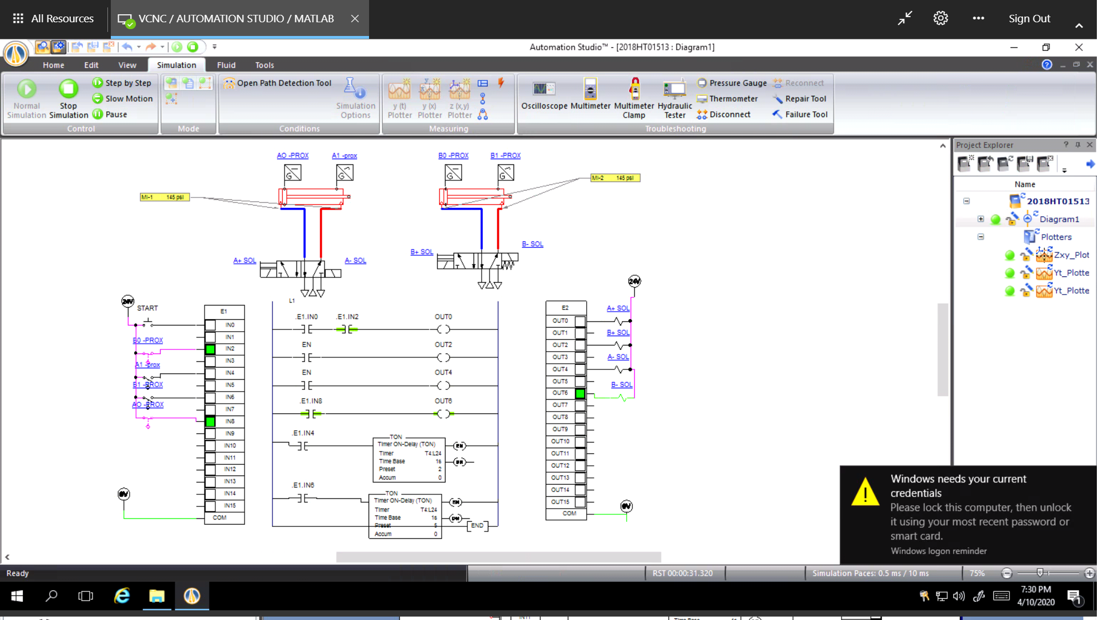

**Differential pressure in each cylinder = 145 psi (10 bar)**

1. Graph of linear speed in cm/s of all cylinders in same graph

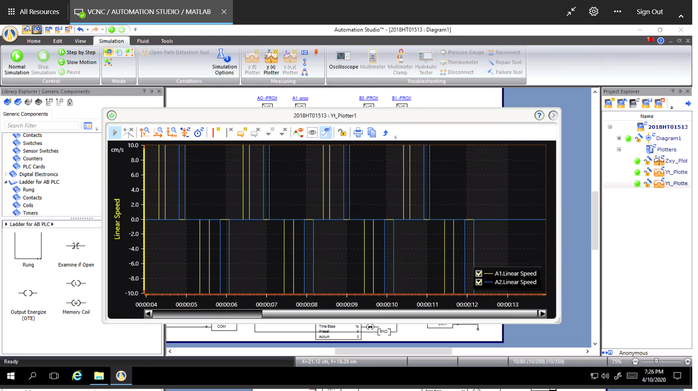

1. Graph of acceleration in cm/s2 of all cylinders in same graph

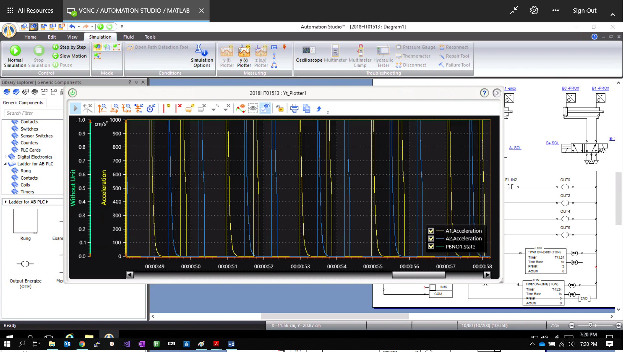

1. Graph of position in mm of all cylinders in same graph

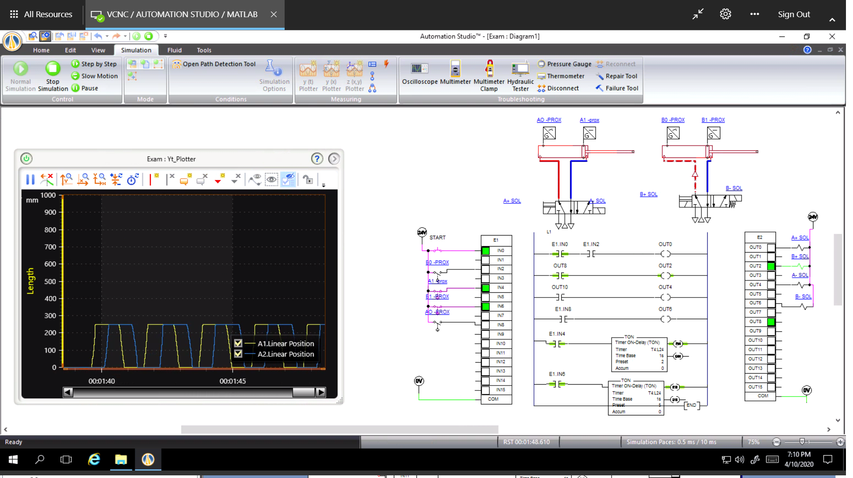

1. Graph (input pressure vs linear speed) of each cylinder as a separate graph